Contants

1. Introduction………………………………………………………………….
2. Aim of the Project…………………………………………………………...
3. Problem Statement & Problem Solution…………………………………….
4. Objective…………………………………………………………………….
5. Project Team & Acknowledgement…………………………………………
6. Diagram & Chart ……………………………………………………………
   1. Use Case Diagram……………………………………………………..
   2. E-R Diagram…………………………………………………………..
   3. Flow Chart……………………………………………………………..
7. Form/Screen Design
8. Advantages & Disadvantages
9. Further Extension & References…………………………………………….
   1. Further Extension ……………………………………………………
   2. References……………………………………………………………...

1. Introduction

This project is aimed at developing a ticket reservation system for Cinema Halls leading to faster transaction times and reduced errors.

This document serves as a comprehensive guide for administrators, developers, and testers to understand the functionalities, architecture, and usage of the system.

# 2. Aim of the Project

This project aims to create an efficient and user-friendly ticket reservation system for cinema halls.

Administrative Module

The system will offer administrators the capabilities to manage the movie catalog, control ticket selling prices, and oversee sales history.

Staff Module

It will provide staff members with the necessary tools to execute ticket bookings and sales effectively

3.Problem Statement & Problem Solution

(i). Problem Statement

**Manual Ticket Processing:** can lead to long queues, increased errors in order taking, and difficulties in tracking sales data accurately

**Difficulties in Reporting and Analysis:**  Generating comprehensive sales reports, tracking popular movies or showtimes, and understanding customer preferences can be challenging with manual systems.

**Lack of Centralized Data Management:** Information related to movies, showtimes, ticket prices, and customer data may be scattered and difficult to access or integrate.

**Scalability Issues During Peak Time** : may struggle to handle a large number of booking requests , leading to slow response times .

(ii). Problem Solution

**Real-time Seat Reservation System:** A visual seating chart that allows to view and select available seats in real-time, preventing double bookings, Selling tickets and optimizing seating arrangements.

**Flexible Showtime Scheduling:** Tools for administrators to easily create, modify, and manage movie schedules .

**Comprehensive Reporting and Analytics:** Generation of detailed reports on total sales ticket and total Earning and total cancel booking ( daily , Weekly , Monthly , and any selected date ) .

**Centralized Database Management:** A robust database to securely store and manage all relevant information, including movie details, showtimes, ticket prices, customer.

**User-Friendly Interfaces:** Separate interfaces designed for administrators and staff, providing role-based access to relevant features and ensuring ease of use.

# 4. Objectives

**Movie Management**: To enable administrators to efficiently manage the cinema's movie catalog, including adding new releases, removing outdated films, and updating movie details.

**Scheduling Management**: To provide administrators with tools for managing the allocation of movies to specific rooms and defining showtimes.

**Reporting**: To implement features that allow administrators to monitor daily sales and generate various reports for financial oversight and strategic planning.

**Ticket Sales and Booking**: To develop a user-friendly interface for staff to facilitate ticket sales and manage customer bookings effectively.

# Project Team & Acknowledgement

1. Project Team

|  |  |
| --- | --- |
| Leader | Han Htet Soe |
| Members | Thein Than Zaw Kyi Pyar Myat Htet  Su Latt  Myo Aung  Ye Min Thu  Naing Htet Lin  Thein Than Zaw |

# (ii) Acknowledgement

The successful completion of this project would not have been possible without the support and guidance of several key individuals.We extend our appreciation to:

[Sensei May Phyu Htun] -- invaluable assistance in managing the project, providing overall direction .

[Sensei Kyaw Zay Oo] -- with their expertise and guidance during the system design phase, which was crucial in shaping the architecture of our application.

[Sensei Khin Wai Wai Kyaw] -- for their support and guidance in overall database design.

1. Diagram & Chart

# Use Case Diagram

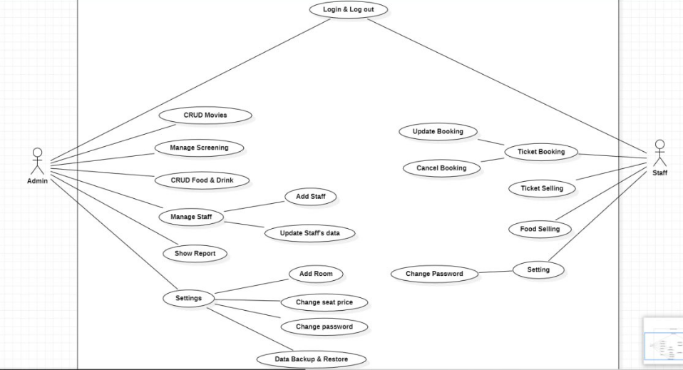

# E-R Diagram

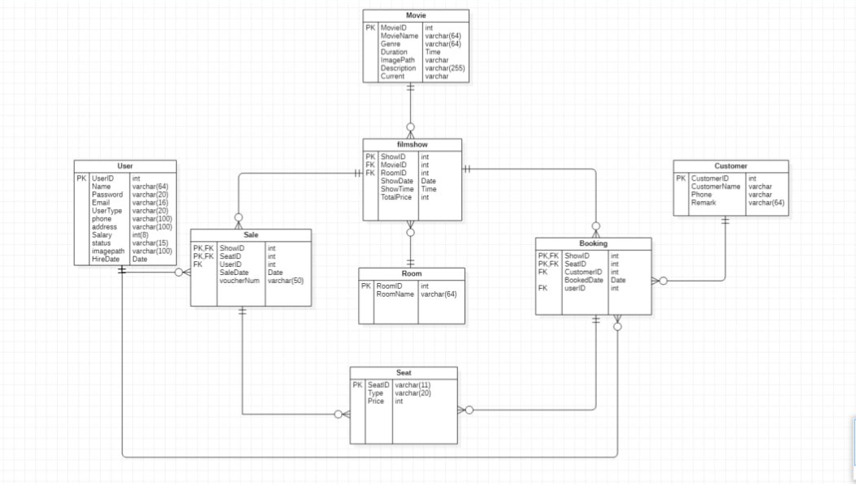

# 6.3. Flow Chat

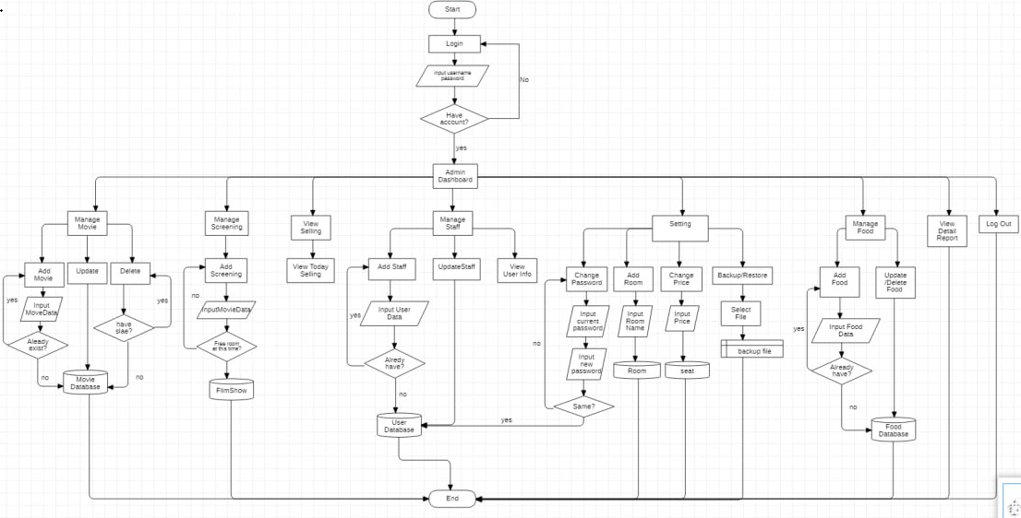

Admin Flow Chart

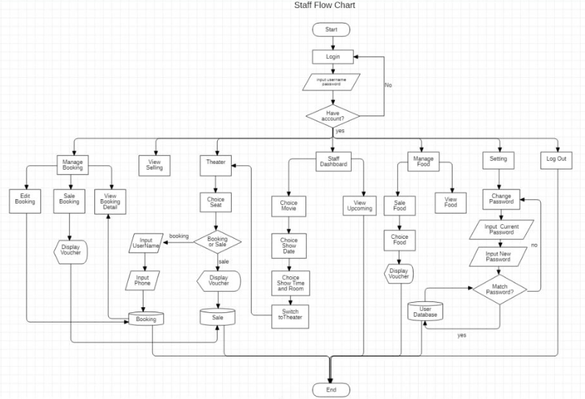

Staff Flow Chart

# .Form/Screen Design

Log In Page

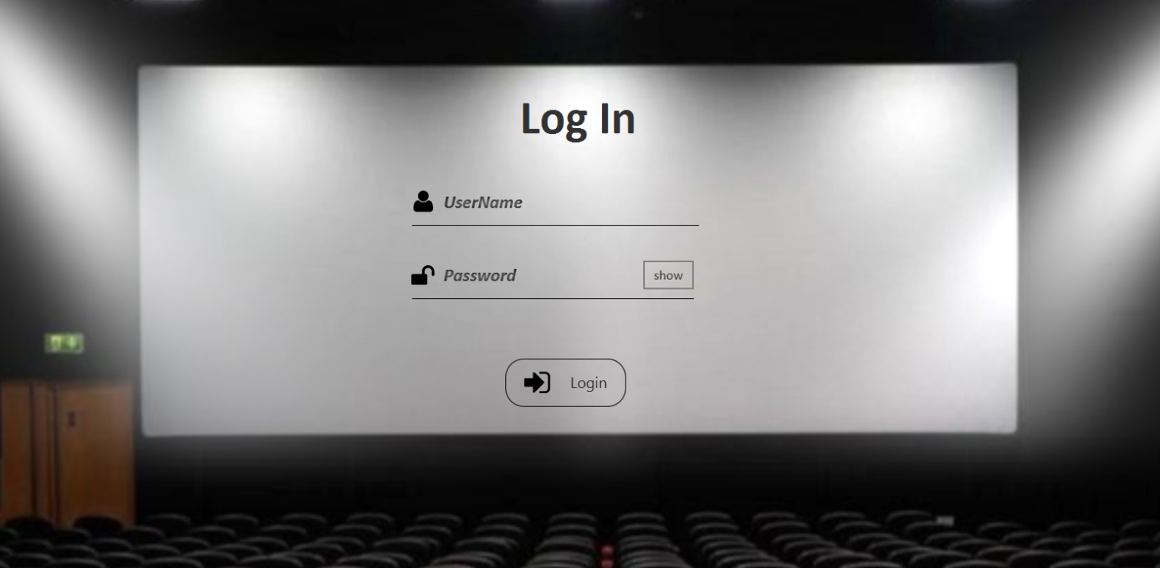

Admin Dashboard

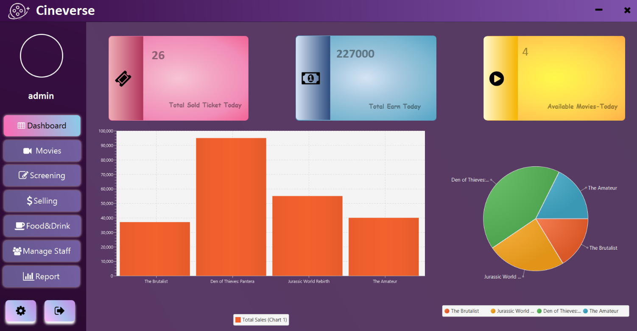

**Daily Selling**

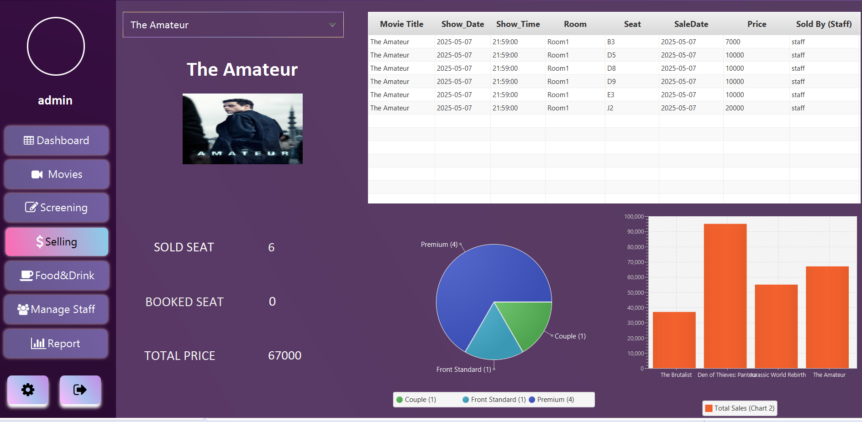

**Manage Movie**

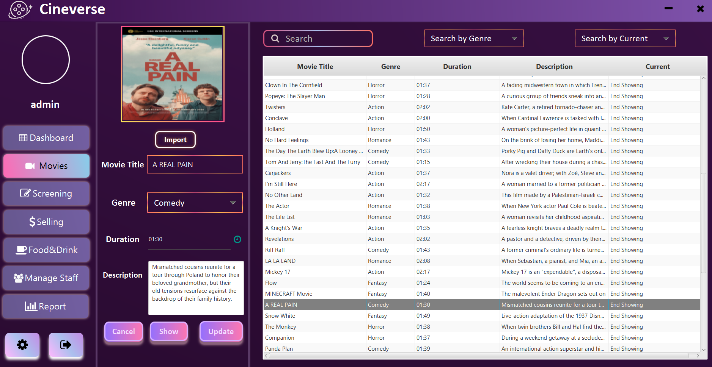

**Manage Screening**

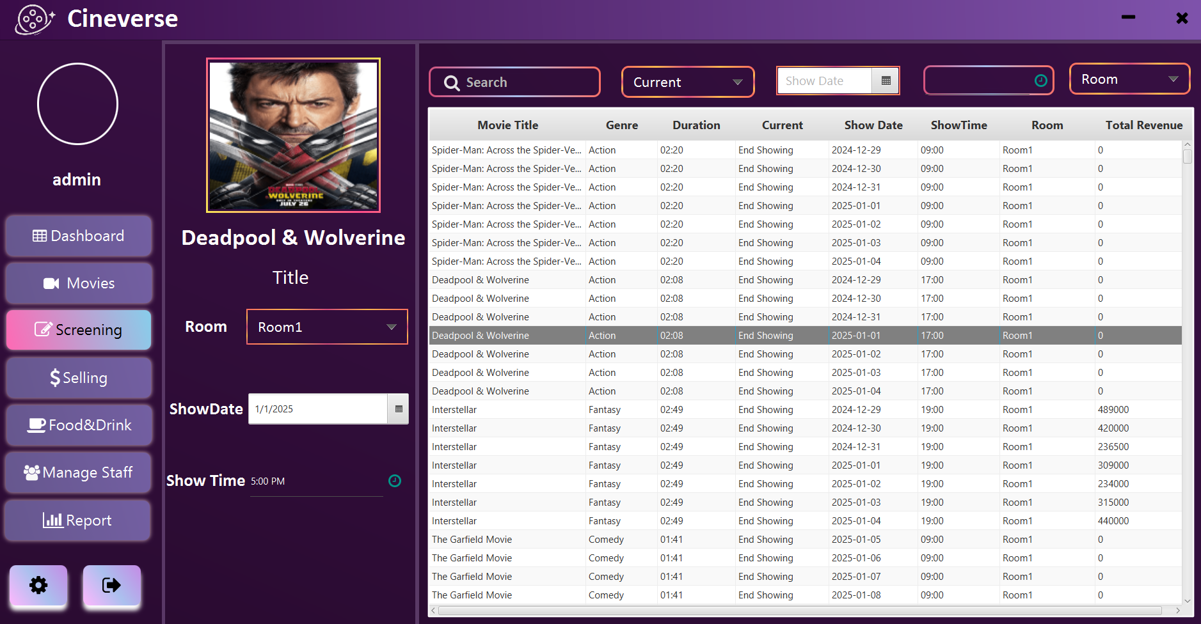

**Report Analysis**

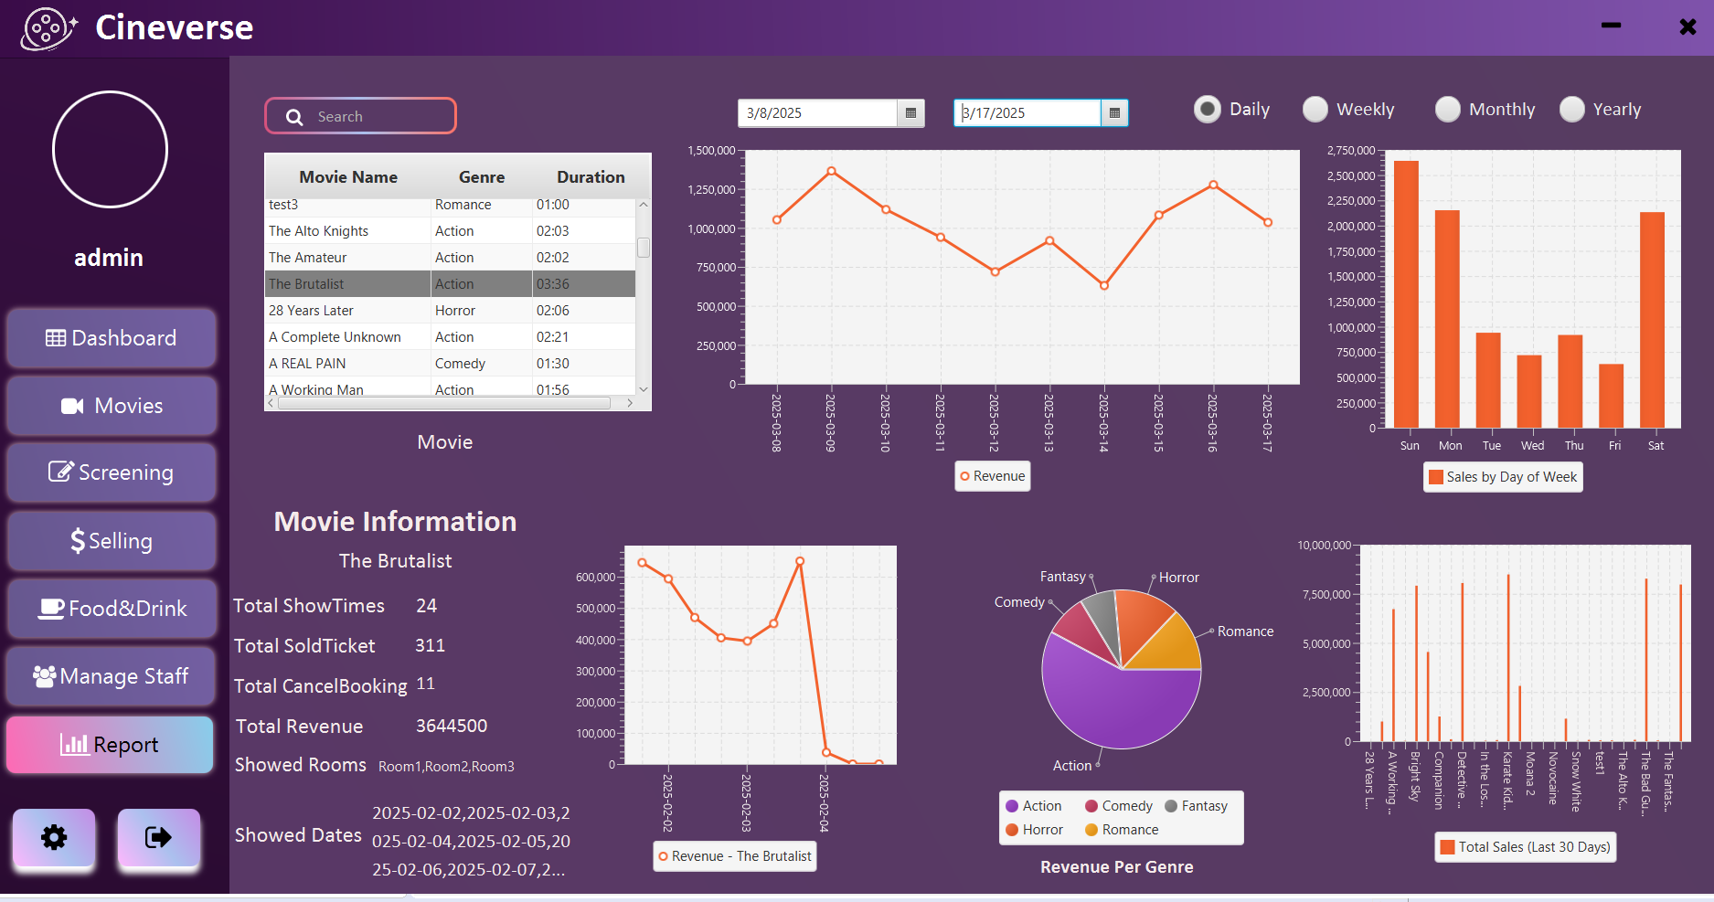

**Staff Dashboard**

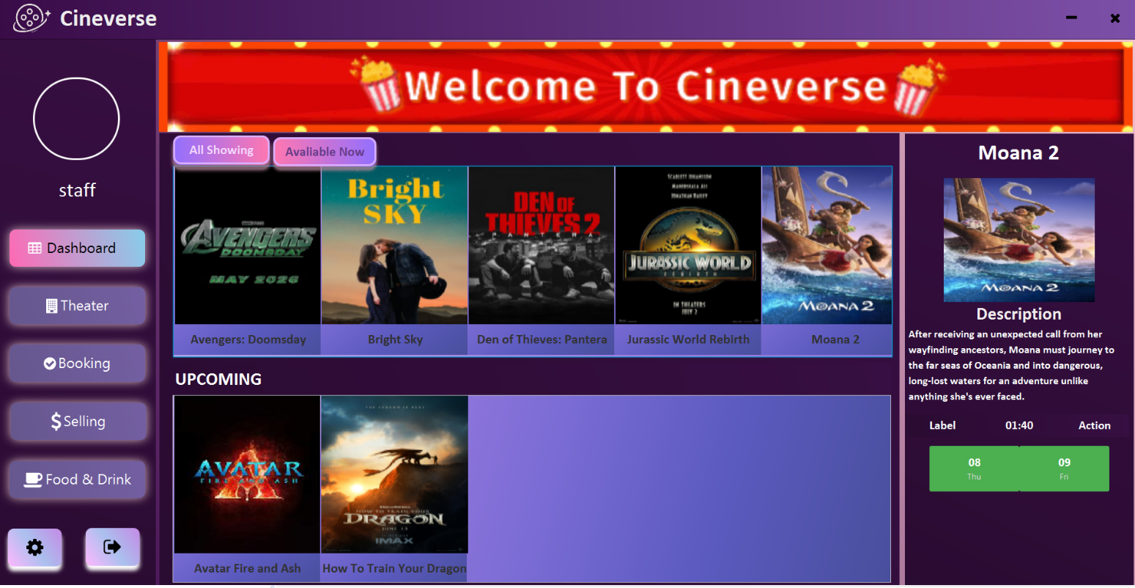

**Theater View**

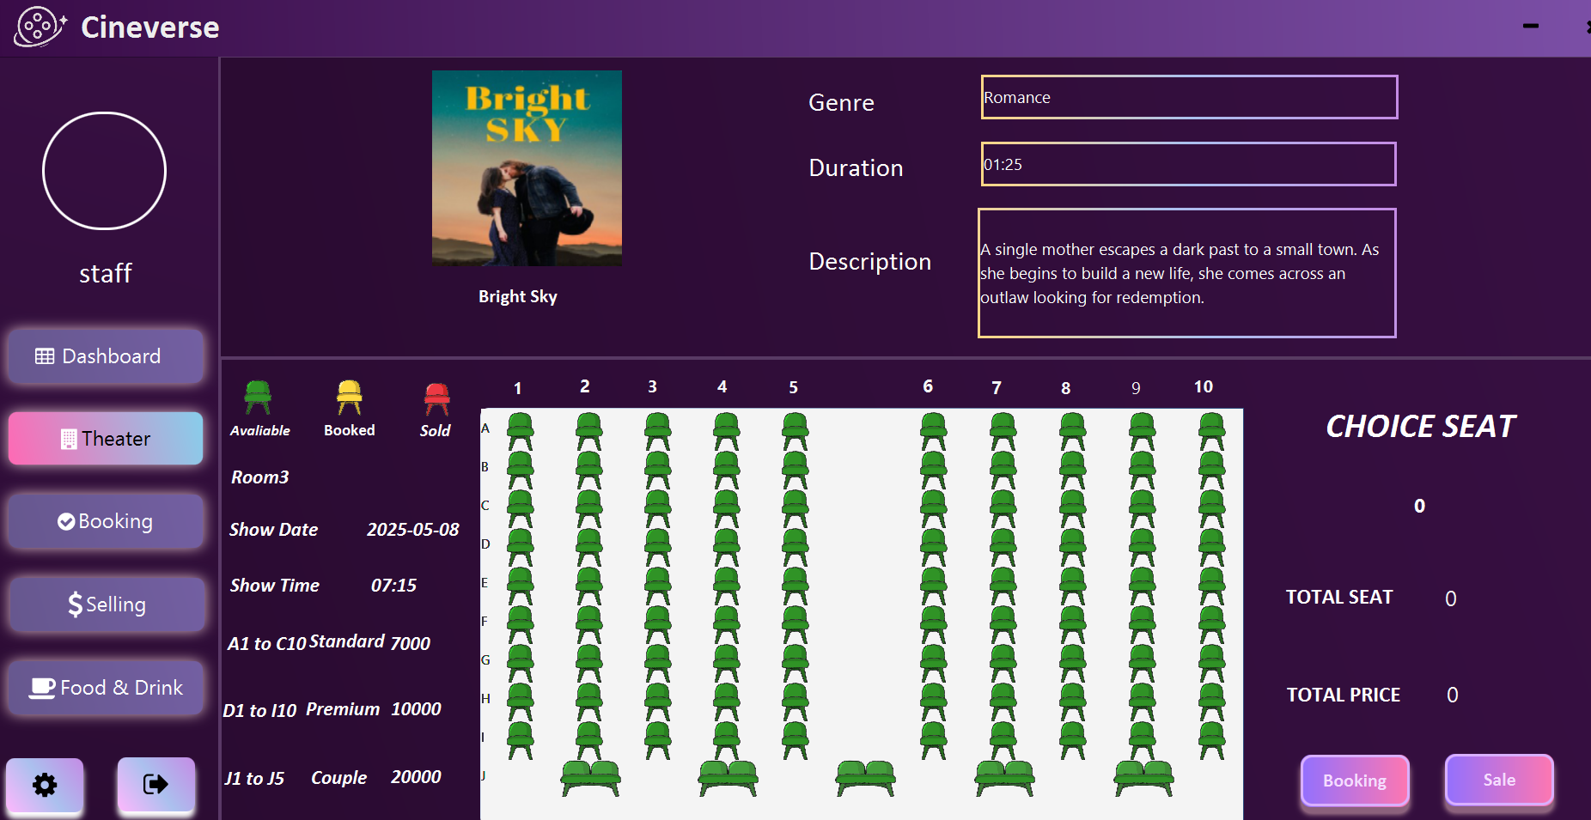

# Advantages & Disadvantages of System

* Advantages
* Faster Transaction Processing
* Streamlined Booking Management
* Reduced Waiting Times
* Accurate Booking Information
* Reduced Errors and Losses
* Disadvantages

* payment limitation

# Further Extension & References

* Further Extension
* Online Payment Integration
* Flexible Room Setup
* Food and Drink Reporting
* A new user ( Customer) section
* References
* <https://www.youtube.com/@marcomanchann>
* https://colormagic.app/
* https://getcssscan.com/

Advantages & Disadvantages